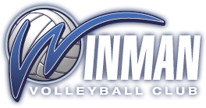

Kevin Jaworski

Kevin Jaworski is a fully certified NCCP Developmental Coach and is working towards his NCCP Advanced Developmental Coach certification. He will be entering his 16th year coaching volleyball with experience at the club and collegiate level. Kevin has experience as a head and assistant coach with Winman for the 14U, 15U, and 16U age groups.
Kevin is an English teacher at Springfield Collegiate and has coached the varsity boys volleyball teams since 2010. During his time there, his teams have won two KPAC Tier 2 championships and have consistently been competitive within the conference.
He is looking forward to coming back to coach for the Winman Volleyball Club to help young athletes develop their skills on the court and contribute to their love of sports.

mrjaworski.sci@gmail.com (C) 204 509-0016

